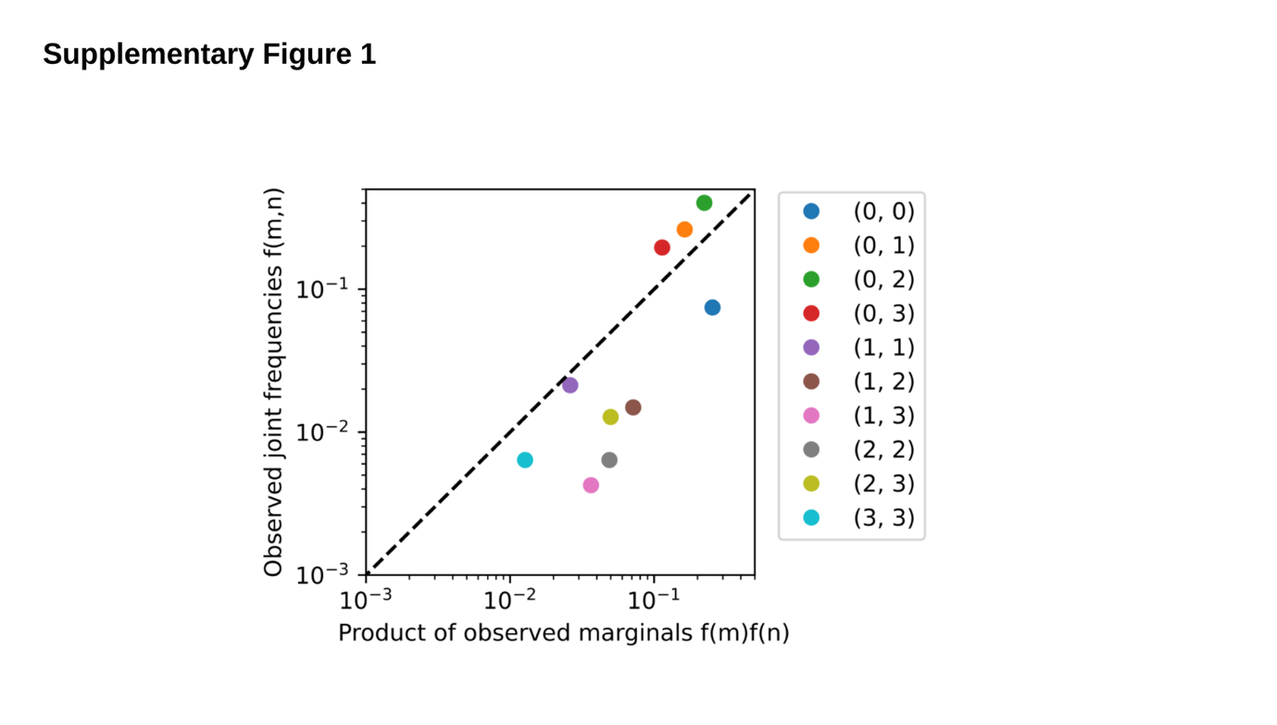Supplementary Figure 1. Interdependence between the first and second hit of APC.
The observed distribution of biallelic genotypes in CRCs in 100kGP (n=1,037), against the product of the marginal observed distributions of monoallelic mutations, evidences interdependence between the two mutations (chi=528.31, P< 0.0001). Different colors refer to different biallelic genotypes. Genotype (M,N) denotes a truncating mutation in region R_{M} in one allele and a truncating mutation in region R_{N} in the other allele. Regions are defined relative to the 20AAR domains, such that a single truncating mutation in region R_{i} leaves i intact 20AAR repeats, where i can be 0,1,2 or 3.

